Effect of carbon doping on Ge(001)/Mn₅Ge₃ thin films grown by magnetron sputtering technique

A. Alvídrez-Lechuga¹, R. López-Antón², L. E. Fuentes-Cobas¹, J. T. Holguín-Momaca¹, C. Santillán-Rodríguez¹, S. F. Olive-Méndez¹

¹Centro de Investigación en Materiales Avanzados, S.C. (CIMAV), Miguel de Cervantes 120, C.P. 31136, Chihuahua, Chih, Mexico.
²Instituto Regional de Investigación Científica Aplicada (IRICA), Departamento de Física Aplicada, Universidad de Castilla-La Mancha, 13071 Ciudad Real, Spain.
Email: adriana.alvidrez@cimav.edu.mx
In the last decade Mn₅Ge₃ thin films have attracted much attention due to their magnetic and structural properties, well-suited for spintronics [1]. One of the major challenges on the design of spintronic devices, as the spin-FET, is the achievement of spin injection into a semiconductor at room temperature (RT) [2]. A heterostructure that provides a better approach for this purpouse is a ferromagnetic (FM)/semiconductor multilayer with a Schottky barrier at the interface. Mn₅Ge₃ compound has become an important material for its FM ordering with a T_{C} = 296 K, that increases with carbon doping. The hexagonal crystal structure allows the growth on Ge(111) substrates within a lattice mismatch of 3.7%. However, Ge(111) is not compatible with the Si(001) technology [3]. Ge(001)/Mn₅Ge₃ heterostructures offer the possibility of spin injection into IV-group semiconductors.
This work shows the synthesis and characterization of Ge(001)/Mn₅Ge₃ thin films elaborated by magnetron sputtering using the solid phase epitaxy (SPE) method at 250 °C. Figure 1(a) shows the bi-dimensional grazing incidence x-ray diffraction (2D-GIXRD) patterns collected at beamline 7.1 MCX (Elettra Synchrotron) for a sample without carbon and (b) a sample doped with carbon. Both patterns show discontinuous Debye rings that are associated to the texture. Figure 1(c) shows a representative high resolution transmission electron micrograph related to the epitaxial growth of a sample grown by co-deposition of Mn and C, followed by a co-deposition of Mn, Ge and C.
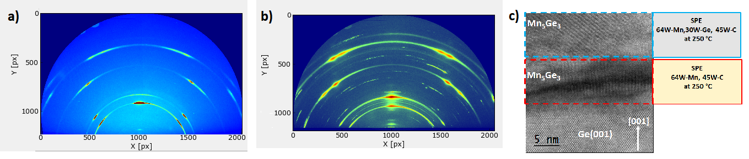
Figure 1. 2D-GIXRD comparison between a sample (a) without carbon and (b) a sample doped with carbon. (c) A sample grown by co-deposition of Mn and C, followed by co-deposition of Mn, Ge and C.
References
[1] A. Alvídrez-Lechuga, R. López-Antón, J. T. Holguín-Momaca et al 2016 Thin Solid Films 616, 111–115.
[2] A. Alvídrez-Lechuga, J. T. Holguín-Momaca, C. R. Santillán-Rodríguez et al 2017 Superficies y Vacío 30(4), 61-64.
[3] A. Alvídrez-Lechuga, R. López-Antón, L. E. Fuentes-Cobas et al 2018 J. Alloys Compd. 762, 363-369.

