Upgrade Challenges at a 2nd Generation Ring
M.L. Marceau-Day¹
¹Center for Advanced Microstructures and Devices, CAMD, Louisiana State University, 6980 Jefferson Highway, Baton Rouge, Louisiana, United States

Abstract

Recently, the CAMD facility, a 1.3 GeV, 2nd generation synchrotron source, has been planning some major upgrades. Though funding has not been completely secured, several steps have already been initiated. In September of 2008, Hurricane Gustav, severely impacted Baton Rouge. The radiation monitoring computer was lost. There is a pending proposal for a new radiation monitoring system designed to upgrade, rationalize and modernize radiation monitoring equipment at the CAMD facility through the judicious addition of select pieces of equipment that would reduce perceived risk and increase overall monitoring capabilities. This approach should significantly reduce the time for commissioning of new upgrades for the facility, by making available sufficient numbers of detectors. It is clear that each CAMD machine upgrade carries with it the potential for increased radiation as a consequence of enhanced energy or flux.

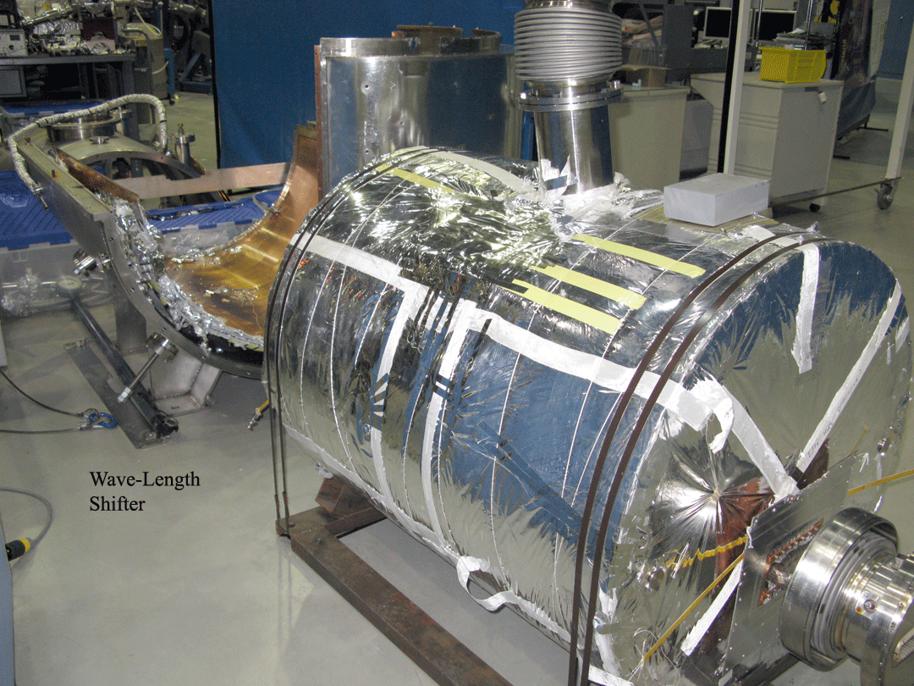
Fig.1 – Removed 7T Wiggler from the CAMD storage ring

Knowledge of how and where losses occur remains an important feedback parameter for machine optimization in addition to radiation safety. The first upgrade, attachment of a He cryostat to a 7T wiggler, began in January. Removal of the wiggler (Fig.1) created new radiation patterns and elevated radiation readings during injection but not during the ramp file. Additional shielding had to be implemented. There is a proposal to replace the 7T wave-length shifter with a new super-conducting wiggler of 7.5 T. Two additional undulators are also proposed. Since the operating energy of the ring is severely constrained by the low energy injection, the Linac will be upgraded from 200 MeV to 300MeV injection and the injection rate increased from 1 Hz to 5 Hz. (Eq.1)

Watts [Power] = [eV] x [Hz] x [sec] x [Amperes] (1)

This necessitates moving the klystron gallery from the Linac tunnel to the experimental hall floor. Some of the issues to be addressed here, in addition to the increased power density, include the possibility of radiation from the klystrons, the waveguides and the potential for dark current. The output from the power density alone could conceivably increase radiation 6.9 times from current approved operational modes.

